SolutionPeace.com
Is Global Total World Peace
Send this out to International Presidents, Top CEO Leaders + Press. Join our Crusader master educator teams with your other networked groups now, no delay as trillions of real $$ at stake.
TOTAL PEACE is achieved once Mass Press Conferences by World Leaders occur announcing the following:
'We are the very first free nation to eliminate All Corruption + Crime and restore total Democracy to WE the PEOPLE'
### WORLD PRESS RELEASE Statement. BuiltByKeith.com 2019-11-24 © (tm) IP rights granted for all to USE by taking ACTION.
"We announce we have the worlds last system of economic redistribution of crime wealth back to our people and simple systems to migrate millions then billions of our people to new areas of remote undeveloped natural resource rich communities that are now self sufficient free water, energy, all digital sustainable marketplaces. We ask for your immediate help to distribute this one Press Release World Announcement to everyone to bring about total World Global Peace. Now our people own and control all aspects of education, marketplaces, stock market, banks, real estate, agri-farms, community centers, parks, roads, transportation systems (electric IOT everything).
We require and request NO ONE riot or hold mass protest rallies as that just allows terrorists and even political criminals to profit by advertising profits of news coverage that puts more cash into Elite pockets. We have already stabilized all stock markets with ProfitShareHolders.SPACE as the absolute first step to achieve total world global peace.

Our young adults and other honest citizens now travel freely with single Intl ID system of IID shown on FOIA.ONE (freedom of Information Action Open Public Database). Our entire world now bypasses and replaces all forms of corruption at one time as the social equality method of SolutionPeace.com is the new world UNIocracy system of humanity controlling and owning all of our Mutual Creator’s resources. All World events affect each person as our GOd’s world is all interconnected by the human condition of life.
Those who violate laws are the corrupt individuals we now collectively hold accountable to surrender all evidence and publicly list their victims. Otherwise, they are manhunted down by our new judicial system monitored by the public using FOIA open reporting databases of true record. Who are those concerned about the needs of others. Who sees the true reality of our world and reach out to help those impoverished by acts of the Elite?
Acts 4:32 is about all believers sharing their possessions with each other. This is WorldSchoolFund and SolutionHousing systems of peace as we educate ourselves how to uphold laws and to eliminate all the regulations, mandates, laws that only profit the ruling elite.

The redistribution of wealth is from two prime sources, convicted criminals and the elite who are forced to show their accounting records and wealth, the second from millions of wealthy families who migrate to higher elevations and provide 20 to 30% of value of their construction to build the required roads, all digital communication systems, energy, water, schools, medical, and other infrastructure of community centers, churches, parks, green space, transportation systems. All now owned and controlled by each local self-sustained community of free will citizens.
Those who violate laws are now quickly put on trial by We the PEOPLE open public voting system using the simple methodology created and published by world famous Author Keith Brent Duncan from Atlanta GA USA. He alone was forced into JAIL for 5 times for 900 days because everyone refused to show he was robbed and kidnapped by orders of super criminal Robert Dee Rose.
The economic damage has been trillions of dollars in intellectual Property Keith and his scientist teams have gifted to humanity from 1976 forward. These simple methods identify and overturn all corrupt individuals to stand trial for their crimes. The seizure of trillions of real dollars in wealth are now used to construct new all digital sustainable villages in third world impoverished nations starting with Philippines, then other Asia nations of Vietnam, Cambodia, Malaysia, and the slave traded other nations in Africa. The oil stock market is now stabilized by use of TurnOffLights.SPACE and SolutionSafeWater.ORG that truly eliminates need for almost all fossil fuels in next 2 to 5 years.

The current Weapons of Mass Destruction are the secret documents created by the Ruling Elite to steal our assets at corporate levels and control over taxes, those who not only make our laws, but violate laws all to secretly control and dominate over our people. They use our trillions of dollars wealth to hire liar lawyers whose only role is to persecute the whistleblowers and victims of organized crime. These lawyers become the most popular celebrity judges and court officials who are so wealthy and powerful they become our political leaders at all levels. Their salaries are an illusion of their true wealth. The same applies to our corporate system of protected Enterprise Entities that prevents any individual from being held accountable for violating basic accounting and open financial disclosure laws. The weapons of mass destruction are easy to see on the general ledger transaction books the public and stock holders are prevented from auditing. The Elite live off the corporations and seldom personally receive income, therefore they pay no taxes and leverage everyones assets to accumulate billions of real dollars of our toil and labor of our workers.
Our new system requires complete disclosure of all net worth wealth and assets by Feb 28, 2020. Anyone who under reports their asset net worth by 95% estimation audits, is required by our new Constitution to turn over the balance to CreatorKeith.SPACE NGO trust foundation on April 1, 2020 to be used as public direct funds to build schools, medical, roads, energy, water, airports, and the infrastructure systems in 3rd world nations. All legally authorized by order of majority of our people using evote. April 1 is infamous Robert Dee Roses. IID 1-19710401-1 (integrity rating return -99%)

Our people are uneducated for a very specific reason. The elite want slightly educated people to run their malls as clerks and assistants. They want a huge factory workforce who are told to WORK HARDER, DO as you are TOLD or you are FIRED without pay or benefits. They are told by advertisements to BUY MORE, Borrow more, go into debt since everyone deserves to own their own home and car. Buy insurance to pay for unexpected events like death, disability, accidents, fires, theft. All to bring the wealth of GODs people one way into the storehouses of the Stock Options and extreme benefits offered to top Elite Executives.
We the PEOPLE speak the truth of the current reality of the resources earned by you are being systematically captured by the few known as the New World Order, New world government, Illuminate, mobsters, and other most accurate terms. Some refer to the Elite as ET Extraterrestrials as reported by Corie Goode and and Alex Collier. The ‘Global Galatic Leqaut of A few of the ELITE design and want crimes against humanity and self-genocide since they are safely hidden in their fortresses in remote islands, their mega yachts like the ‘DIXIE ROSE’, and have aircraft to escape any world war four.
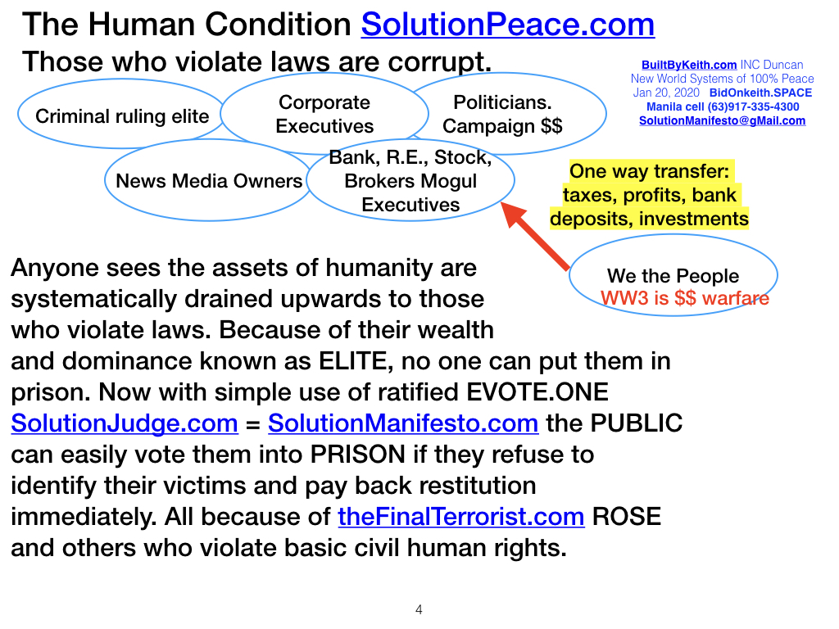
World War Three is the cyber crime terrorist attacks conducted hourly on our computer data centers. Simple use of a low level password and back door access enable billions of real dollars transferred to outside accounts used to build more fortresses including all the hidden safe deposit boxes of gold, diamonds, stock certificates, and of course the most critical information, the accounting books that are mostly digital in nature.
The four key aspects of our new world society eliminates the ability of anyone at any level from violating laws and escaping the justice of our new legal court system.
The first is returning the economy back to WE THE PEOPLE when all our National Presidents and top CEOs with host mediator Keith Duncan’s R&D groups conduct the worlds last Open Public Peace Summit on Jan 20, 2020.
- UNIocracy.org is the new world society owned, controlled, and run by humanity as free citizens to conduct open trade worldwide with free communication and Education provided by WorldSchoolFund.com.
- SolutionManifesto.com is the new UNIocracy society single world constitution that protects the civil rights of everyone with no exception.
- SolutionHousing.org migrates billions of persons to higher elevation as the true transfer of mega trillions of real value wealth is owned by the few who must now declare their net value by Jan 20, 2020 or face prison for concealing the source of their massive income and wealth holdings.
- ChristDomain.com also achieves total world peace by showing all religion groups how to work in cooperative outreach ministries to solve all their own local issues. Therefore very little government is ever needed again and the mega corporations are downsized by the following simple common stock market system.
- ProfitShareHolders.SPACE returns total control over the leadership and compensation benefits of all executives and management. This is also the new universal standard to eliminate all day traders and stock market manipulation by the ELITE who currently control and pervert all transfers of our wealth to their family run crime dynasties, all by hiding their corporate accounting books, secret contracts, payoff bribes to politicians and underground connections to the billionaires who secretly control everything. We now have a simple method of use of EVOTE and FOIA to identify the flow of information and assets to identify who is NOT paying taxes and who is acquiring massive wealth by violating existing laws.

SolutionMilitary.com One World combined Military is total Global peace for the common sense reason that the eVOTE.one free will citizens decide best use of our military officials and warriors by converting all the war machines to Peace Keeping tools. The current WMD Weapons of Mass Destruction are the paper chase secret conspiracies conducted by a few Corporate Executives known as the 'Criminal ruling Elite' who murder and persecute our most righteous Research and Development scientist warriors who fearlessly protect the rights of all others as the only answer to teach humanity how to ensure the integrity enforcement of the most basic human rights seen on SolutionManifesto.com and enforced by all elected system of both Government and Corporate leaders who work for the people, not their family dynasties.
The four basic components of our Military are Command, Communication, Control, and Care.
1. Command: The first required step is use of client3635.wix.com/CCWGuard to teach all communities how to protect their own community properties with simple use of psychology, centralized call-out list of residents and visitors, and use of free internet communications so everyone in world knows WHO is WHO of open public database FOIA.ONE deployed at local level and then combined at Interpol International level.
2. Communication: The second required action is use of cell phones by all military and police at all levels. With automatic face recognition and use of photos and video, anyone committing a crime or investigated now goes on public display in FOIA.ONE to ensure that justice is served immediately without ability for a wealthy person to intimate key witnesses and walk free because they extort our judges and pay off the liar-lawyers.
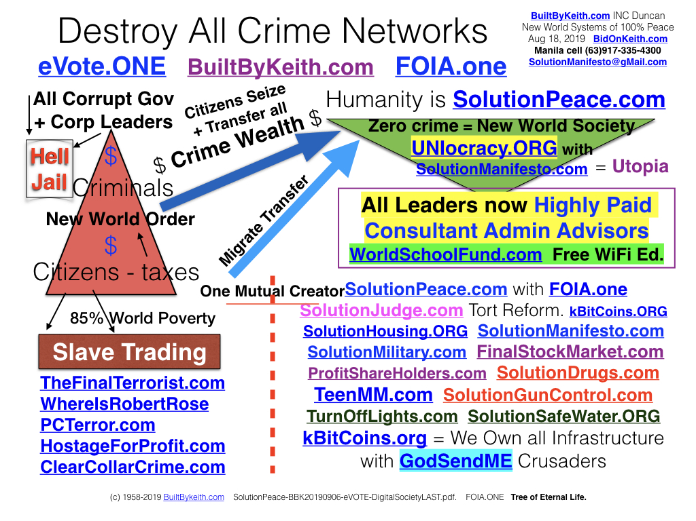
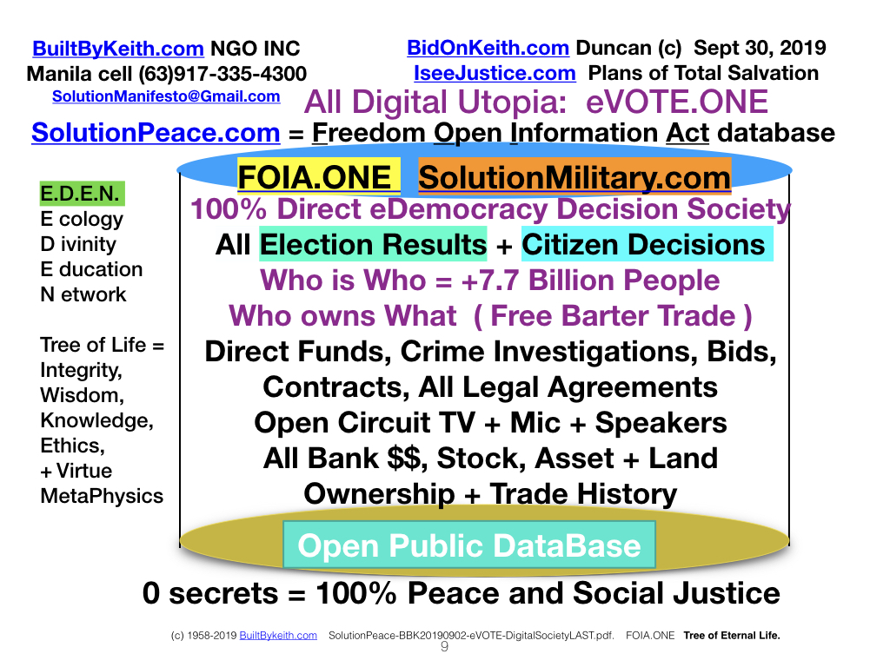
3. Control: SolutionJudge.com is the basis for our new judicial system deals with violators at community level by elected officials of the court. This simple method of fairness ensures that false witness and hearsay is punished when the evidence indicates to eVoteing public that a person is not telling the truth by inability to present irrefutable testimony and supporting video, photos, certified and supporting documents.
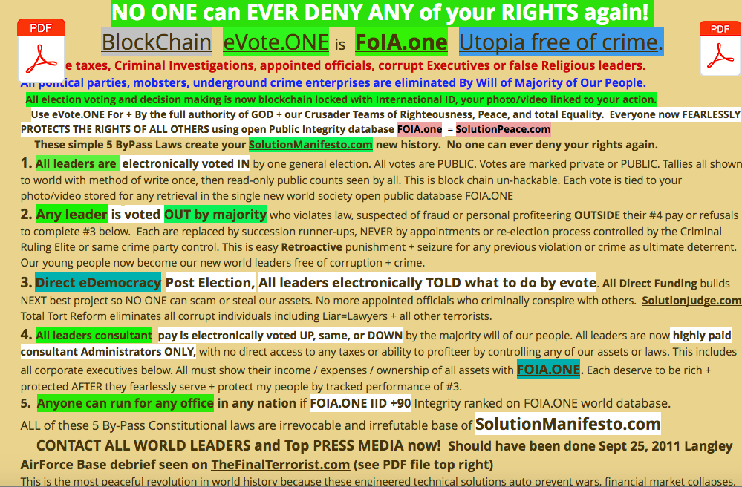
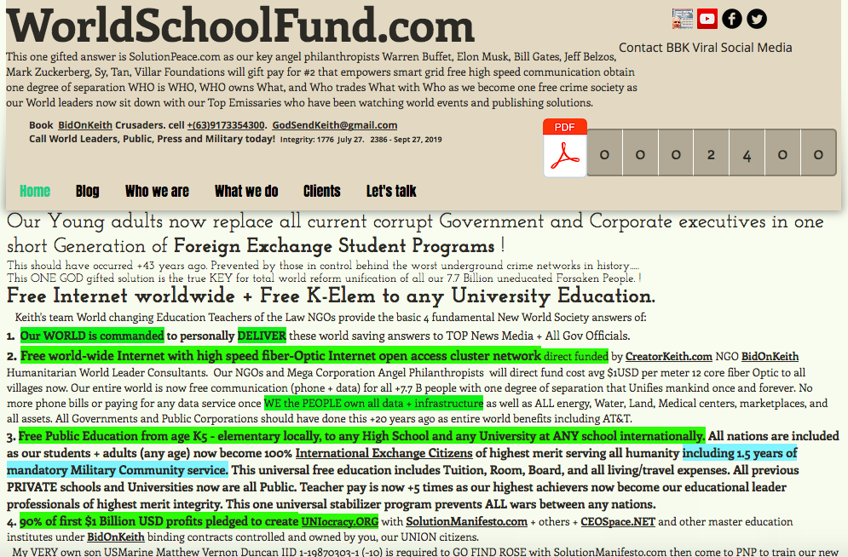
4. Care: When local community officials at government and corporate level refuse to be internally investigated, our military investigators are dispatched as a last resort to obtain the required evidence and testimony.
5. Because of the integrity design of our new military forces, no President, Congress, or rogue group can ever use military force to wage war on any other culture or faction ever again.
6. Any violations by a military personnel including top generals are taken to military open public court. If the court decides this is a civil violation, the person is taken to court at community level.
7. The International Court of Justice in Hague now focuses on Wide spread Human Right Violations.
The Best use of our old weapons of war is now Peace Keeping instruments of Social Equality and Peace.
Nuclear Aircraft carriers and support ships now are portable gigawatt power plants and hospital ships to evacuate in case of plague, natural disasters or even massive terrorist attacks on our mega coastal cities and refineries. All Military surveillance systems now work together sharing intelligence with the public on world events. No secrets means no wars can be waged by anyone as no nuclear buttons are needed again. We now build safe remote nuclear plants.
Keith and a few are the key Spokespersons sent by key person benefactors to mediate all. if we are murdered from now on, our system of World Peace will quickly find all criminals responsible with Military use of Open Circuit TV eDevices using FOIA.one and SolutionJudge.com We fear no one. the criminals fear everyone once they see their own evidence exposed to public so anyone can claim bounty on their heads.

Everyone now uses EVOTE.ONE to decide the next best project that benefits local and then national interests of our people. No more politics or mega dynasties are allowed with most unique combination of published SolutionJudge.com SolutionMilitary.com ProfitShareHolders.SPACE and kTrader.SPACE become the last new world universal stabilizing methodology ratified by public, all stockholders, and company employees. No longer can any Politician, Political Ruling Party, Corporate Executives, or underground crime network control any aspect of our markets and governments by hiding secrets of their crime syndicates.

Nov 24, 2019 Years 2019 - 25 years is year 1994 in Birmingham. The cornerstone of Riverside methodist Church is example of the the Acts 4:11 ‘Jesus is the stone you builders rejected, which has become the cornerstone’.

With advent of speech to text, our entire world now interprets the truth from any dialect to any other translated dialogue. God and Humanity are both glorified at the same time is John 10:30 ‘the Father and I are one’. Nothing is left out of context as many of our top religious leaders quote scripture after passage and often pervert the original intended teaching solution by ignoring the pre events, reality, and after effects of the original issue. By changing the cause of the issue and related problems, prevention of downline cascading crimes occurs. The cost savings are enormous as everyone knows that designing perfected solutions starts with open lines of communication between those whose tasks is to engineer refined self correcting systems of artificial intelligence known as singularity. The acceptance of universal accepted stabilizing solution methodology is the true answer for achieving sustainable world global peace.

#####
OPTIONAL to READ: still critical: starting with Robert Dee Rose who is TheFinalTerrorist.com. Keith offered to USA Military Sept 2011 to escort them to FBI AG NSA CIA and Interpol to seize ROSE. Since Keith's most valuable 35 years of anti crime technology, software/hardware genius designs of CreatorKeith.SPACE and his extensive databases have been used by ROSE + terrorists since before Aug 2010 to infiltrate thousand of governments and corporations. We have been calling for USA Congressional Investigations for years and have yet to have simple call back from anyone at any level. The most profitable Class Action Lawsuit Miscarriage of Justice is Norfolk VA 4:11cr112 that indicts even DOJ fired AG Sally Q Yates and many more very powerful Atlanta, Norfolk, Raleigh, Washington DC DOJ and Gov officials including mass medical malpractice suits against the most incompetent Doctors sub hired by DOJ.
## end of OPTIONAL translation.

All the result of denial of ALL civil rights that are truly simplified and addressed by SolutionManifesto.com that is the original universal 11 commandments and single Human International Bill of Rights named HIBOR. No ones rights can ever be abused or denied again.
All these most comprehensive URL linked solution set answers are provided by the R&D scientists led by Keith Duncan as anyone can book his teams be PAID with either Common Stock or the most valuable commodity in our world of Intellectual Property. Reference client3635.wix.com/BidOnKeith as he has asked for safe haven refugee protection from the worst cyber criminals and Gov officials who have relentless persecuted him and thousands of others to prevent this monumental Press Conference Action from occurring. Most of these were ready for world leader distribution back in summer of 2010. Our Governments and world leaders owe him the ultimate debt of gratitude by providing him and his crusaders safe passage to the next places of greatest needs. This is to full fill the promises of our fore founders to UNIFY and REFORM all humanity. Please join us in this most peaceful replacement of existing corrupt systems by supporting and direct funding Keiths Next sponsored events. Call/Fly us to your greatest places of needs before mass RIOTS erupt.
This broadcast is updated Oct 16, 2019 as even Trump, Duterte, Putin, and USA ambassador Sung Kim will be madder than HELL that corruption has been legalized decades ago and NO ONE in their very own DOJ, DOD, Interpol, AFP, PNP, Senate, Congress, or other agencies has ever lifted a single finger to contact our top Presidents, Gov officials, and corporate executives. Our other Angel Philanthropists have also been asked to contact Keith and his crusaders and provide the required resources of their R&D scientists to complete this most amazing and powerful ministries of ACTION to create our last Crime Free Society to stabilize all world economies and empower humanity to conquer the last frontier of outer space. Reposting of this World Broadcast to top News Media and over viral social media will also obtain the proper final Action Results."

The Worlds most Powerful Broadcast of R&D methodology in Humanity = God's Purpose is here. Everyone benefits. These methods would have been our worlds new unify solutions back in 2005-2011 era except criminals were cyber stalking our groups and subsequently murdering and persecuting so many of us we were disbanded and isolated up to this moment. These crimes against humanity have never been resolved or even investigated by our DOD DOJ CIA NSA Interpol systems. Therefore we have modeled to world a new bypass replacement Stock Market, Bank, Financial, Law Enforcement, Military, and Judicial system to use our best Integrity focused Scientists and other prime disciplines to showcase with broadcasts how humanity MUST address the transfer of wealth back to our people using these simplified methods starting with ProfitShareHolders.space. This includes addressing the greed issues and exposure of ALL criminals who refuse to surrender. With Majority direct democracy eVote, anyone in world can be isolated or put into prison based only on their own crime evidence in.
These reality Crimes Against Humanity MUST be resolved and prevented by our people since most DOJ + gov agencies were infiltrated by crime networks decades ago and actively PREVENT any terrorist crime investigations and seizures because quite a few of the criminals are at top of Government and Corporate levels who want our people enslaved and even dead. Therefore we collectively replace and bypass all forms of corrupt law enforcement judicial systems by inviting key ethical persons to join SolutionPeace.com and provide the required resources to call on All World Leaders to obtain Global World Peace or be shunned and even put in Prison for their failures to serve and protect mankind. We are the most humble wealthy Venture Angel Philanthropists who have called for Congressional Investigations and direct call
Illegal detention of anyone is a crime based on no accuser appears in front of the accused with irrefutable irrevocable conclusive evidence shown in FOIA.ONE. The rights of a victim will be protected and upheld as a priority over any false accuser. Victims can always counter sue an accuser without violating any other law. Isolation of people and preventing them from their right to speak publicly is a crime. Denial of a persons civil rights is a crime. Knowing a crime and refusing to notify law officials is aiding and abetting conspiracy coverups. This has all happened to Keith himself and millions of our fellow common whistle blower citizens. We lost over $500 Million USD profits and billions of real $$USD Intellectual Property that are these website R&D broadcasts to humanity....
If auto-convicted criminal (by the people) refuses to pay back restitution and ask for forgiveness, they stay in prison forever. By eVOTE system, they applies to anyone including millionaires and Billionaires. as it is always their crimes that indict convict them. No longer can liar lawyers/Judges/others prevent justice from being served as SolutionJudge.com puts anyone on stand of testimony without ability to Plead the 5th.
Most critical is for USA Military, Interpol, CIA, HLS, Presidents, other Angel Philanthropists to dispatch protection to put our Crusaders in safe house while ROSE and other terrorists are seized with our (c)(tm) patented methods as we + they ALL get paid back for service to humanity. For ROSE #1 crime is infiltration of databases and extorting our top DOJ and even military officials to commit crimes against humanity. All world can see he has a $10 Million USD (need more?) bounty reward on his head DEAD or ALIVE.
All legally granted and authorized as ROSE + thousands of others are the most dangerous Enemy of all Nations. We have reverse cyber tracked him for years as soon as he committed any crime, we reported him to Lawyers, Police, then IRS, FBI, AG, USMarshals, Press, Public, + Military. Therefore he CONVICTS himself for refusing to surrender was we have published ALL his contacts and crime network this entire time. This is always responsibility of CIA, Interpol, and Military to protect keiths R&D top scientists as we already legally claimed all assets seized using our famous (c)(tm) patented replacement bypass new world perfected system that true reality solve every single major world issue. There has never been anyone protecting 1st of our rights means NO one protects your rights either = World Demise at any moment.
We require and request NO ONE riot or mass protest rallies as that just allows terrorists and even political criminals to kill off protestors and hide, or claim others made them do it. This happens so often. Piggybacking violence on crowds to create chaos. and Panic then used to easy depopulate any nation with nuclear, poison gas/water, DNA modified food, or even just unleashing the last Subsonic Dark Age modified plaque. Prevented forever once all 'unsaved' criminals are auto ID'ed, seized and put in Hell Jail where they belong. All who join are new world society receive 1% of all crime assets seized with CreatorKeith.space 75,000 Common shares of stock modeled after Warren Buffet who must be contacted to come find us as we did ask back in 2010 summer through Chris Morris CMAFinancial.com "Marlin' and his Netjet Pilot in Atlanta GA and have been broadcasting continuously since most famous kidnapping Oct 3, 2011 of all time ordered by Terrorist ROSE.

Nov 24, 2019 Add on to all.
Years 2019 - 25 years is year 1994 in Birmingham. The cornerstone of Riverside methodist Church is example of the the Acts 4:11 ‘Jesus is the stone you builders rejected, which has become the cornerstone’.

With advent of speech to text, our entire world now interprets the truth from any dialect to any other translated dialogue. God and Humanity are both glorified at the same time is John 10:30 ‘the Father and I are one’. Nothing is left out of context as many of our top religious leaders quote scripture after passage and often pervert the original intended teaching solution by ignoring the pre events, reality, and after effects of the original issue. By changing the cause of the issue and related problems, prevention of downline cascading crimes occurs. The cost savings are enormous as everyone knows that designing perfected solutions starts with open lines of communication between those whose tasks is to engineer refined self correcting systems of artificial intelligence known as singularity. The acceptance of universal accepted stabilizing solution methodology is the true answer for achieving sustainable world global peace.

